**Bionic Arm**

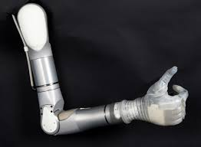

**Team Members:**

Kunal Awari (Coding)

Nikhil Motagi (Electronics)

**Components Used:**

Arduino Uno

Servo Motors (4)

PCA9685 Motor Driver

**Libraries Used:**

Adafruit_PWMServoDriver.h

**Description**

It is a 6 axis bionic arm that can be controlled by a person who is wearing the controller in his/her arm .It uses 6 servo motors to control the motion . Currently it is in the developing stage